https://www.lexpress.mu/article/401149/promotion-lindustrie-50-reconnaitre-numerique-lintuition-linnovation-et-creativite
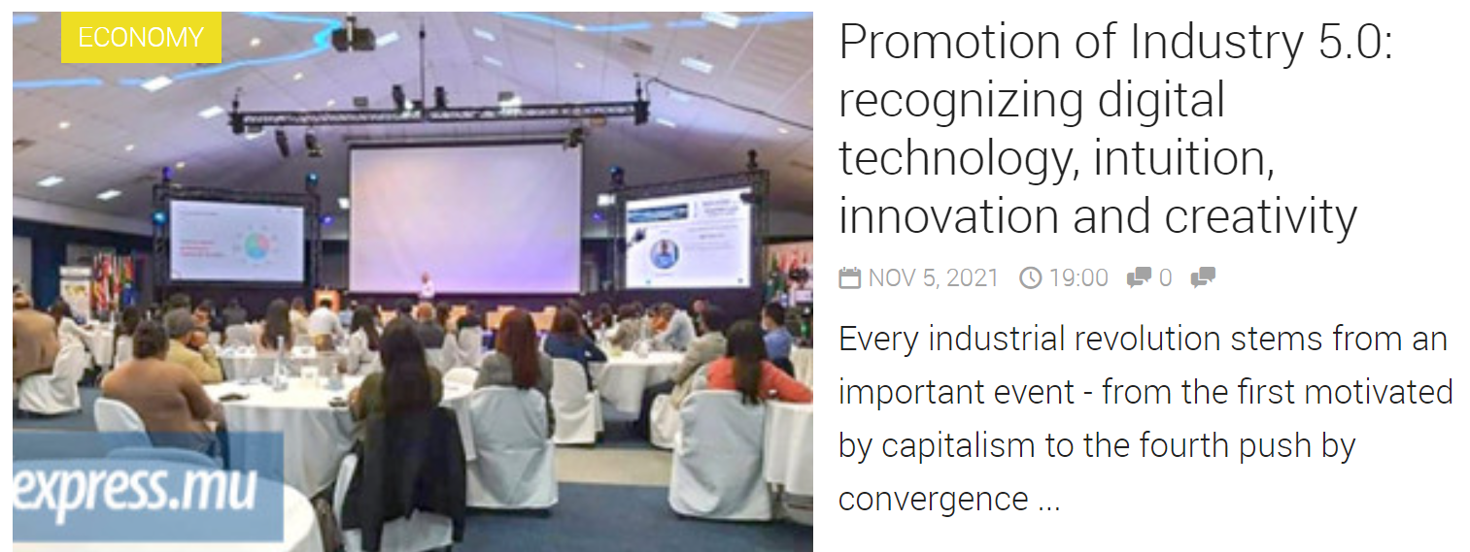
Every industrial revolution stems from an important event - from the first driven by capitalism to the fourth driven by physical, digital and biological convergence for optimization. The Covid-19 pandemic has led to a fifth linked to resilience and sustainability.
Despite the advances, Africa, including Mauritius, is still in the era of industry 2.5. Chee-Peng Tan, i50 / SDG Secretariat Chairman and founder of Team SYNthesis (Mauritius & Africa) Ltd, explains that awareness of the 4.0 revolution has been low globally. Even some industry leaders, especially in Mauritius, had never heard of it. On the contrary, the opinions were that the fourth industrial revolution is heavy in terms of technology, therefore heavy in investment and not very affordable. Because companies have always set their priorities based on return on investment and pursue any initiative with significant benefits. But this industrial revolution is not intended only for the manufacturing sector. There is FinTech in financial services, SmartAgri in agribusiness and EduTech in education, among others.
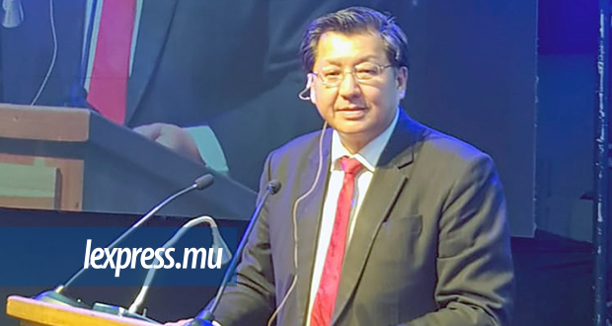Chee-Peng TAN, i50 / SDG Secretariat Chairman and founder of Team SYNthesis (Mauritius & Africa) Ltd.

Given the lack of knowledge of Industry 4.0 over the past five years, Team SYNthesis wants to persuade more African leaders to embrace the Fifth Industrial Revolution. "When we emerge from the woods of the pandemic, we will have to be taller than the trees," explains its founder, who adds: "Survival is now reserved for the fastest of the fittest." On the one hand, large organizations are already well on the way to digital operations readiness, and on the other hand, the typical small and medium-sized business (SMB) needs to innovate.
Chee-Peng Tan cites, as an example, the artisanal SME which has business difficulties due to sales aimed only at tourists where the automation of the production workshop is not the problem. Based on the reactions of some outlets, which continued to supply foreign customers who had previously bought from them, the SME finds that artisanal products lift the morale of those who were locked in by the lockdown and that the star products were those with personalized messages. The business model has shifted to online selling with the personalization of mass messages. "This is an example of Evolution 5.0 where the jobs of artisans have been saved and where human design meets human needs."
According to the i50 / SDG Secretariat Chairman, the 5.0 mindset is necessary to promote the place of people at the center of everything. The approach of this new industrial revolution is centered on people and digitization, moving from the new normal to the next level. "Industry 5.0 humanizes technologies and promotes massive customization: human technology where human design meets human needs, recognizing that digital advancements, intuition, innovation and human creativity are all important." This is at the beginning, in the middle and at the end of automated operations.
It is important to support and empower workers rather than replacing them, to acquire more skills, to have personalized and cheaper products to increase customer loyalty and satisfaction. In addition, it helps reduce waste and costs, and make production faster. Efforts continue to bring strong collective action across all sectors and encourage leaders to begin industry transformation in the face of the Covid-19 crisis. It is in this context that the last Masterclass on Industry 5.0 took place, organized by Team SYNthesis (Mauritius & Africa) Ltd , in collaboration with the University of Mauritius and the University of Technology, Mauritius Research & Innovation Council and Harel Mallac Technologies , October 22.
The theme was Reimagining and Rethinking Innovative Sustainable Development Towards a Diverse Future. This virtual international conference hosted participants from 43 countries at the Ravenala Attitude Hotel, bringing together 35 international speakers/panelists from 13 countries and local personalities.

